**Test cases:**

**Requirement 1**

Sign up:

1. All information is in the correct format：

Input:

email_address: zhangsan@example.com

username: zhangsan

password: Test123

output:

sign up successfully and jump to the login page

2. Submitting with black value:

Input:

Input:

email_address:

username:

password:

output:

error message: Invalid Email Address

3. Invalid email address:

Input:

email_address: zhangsanexample.com

username: zhangsan

password: Test123

output:

error message: Invalid Email Address

4. Leave the password blank:

Input:

email_address: zhangsan@example.com

username: zhangsan

password:

output:

error message: Please fill in all required fields.

5. Weak password:  
Input:

email_address: zhangsan@example.com

username: zhangsan

password: test123

output:

error message: Password must contain an upper and a lower letter.

6. Already registered email address:

Input:

email_address: zhangsan@example.com

username: zhangsan

password: Test123

output:

error message: This email has been registered already.

7. Capitalized email address:

Input:

email_address: Zhangsan@example.com

username: zhangsan

password: Test123

output:

sign up successfully and not report ‘This email has been registered already.’

Log in:

1. Valid user log in:

Input:

email_address: zhangsan@example.com

password: Test123

Output:

Log in successfully

2. Unregistered user:

Input:

email_address: lisi@example.com

password: Test123

Output:

Error message: User does not exist

3. Incorrect password:

Input:

email_address: zhangsan@example.com

password: Test1234

Output:

Error message: Incorrect password

**Requirement 2**

1. successfully buy

Input: Buy 500 shares, AAPL, 4/11/2023.`

Output: balance 1000000->918900, AAPL volume 0->500 shares.

2. successfully sell

Input: Sell 100 shares, GM, 4/11/2023.`

Output: balance 677996->681537, GM volume 200->100 shares.

3. invalid volume

Input: Buy 0 shares, AAPL, 4/11/2023.`

Output: error message: Please enter a valid trade volume and select a trade type

Input: Buy -1 shares, AAPL, 4/11/2023.`

Output: error message: Please enter a valid trade volume and select a trade type

4. didn't select trade type

Input: 100 shares, AAPL, 4/11/2023.`

Output: error message: Please enter a valid trade volume and select a trade type

5. not enough money

Input: Buy 999999 shares, AAPL, 4/11/2023.

Output: error message: Please enter a valid trade volume and select a trade type

6. not enough shares

Input: Buy 999999 shares, AAPL, 4/11/2023, while I only have 500 shares.

Output: error message: You do not have enough position.

**Requirement 3**

1. test valid symbol

Input: search ‘AAPL’

Output: get stock information, recent news, trading price and several advanced charts show its recent five years’ historical price.

2. test valid symbol with lowercase letters

Input: search ‘aapl’

Output: get stock information, recent news, trading price and several advanced charts show its recent five years’ historical price.

3. test invalid symbol

Input: search ‘Invalid’

Output: error message: Invalid stock symbol. Please try again.

4. test suspended stock

Input: Search for stocks that have been suspended in recent years, like ‘CO’

Output: error message: Invalid stock symbol. Please try again.

**Requirement 4**

For users’ page:

1.

Input: Users hold less than two stocks

Output: error message: The number of stocks in current portfolio is less than 2. Add more stocks to analyze the risk return.

2.

Input: Users hold more than two stocks

Output: Get a chart that show where the current portfolio weighting is located on the risk/return graph. Also the Sharpe ratio.

For admins’ page:

3.

Input: All stocks held by all users are less than two

Output: error message: There are less than 2 stocks in the overall portfolio. Wait more stocks in the overall portfolio to see risk return analysis.

4.

Input: All stocks held by all users are more than two

Output: Get a chart that show where the current portfolio weighting is located on the risk/return graph.

5.

Input: All stocks held by all users are more than 15

Output: Due to the large number of stocks, the EF function takes too long to run and the admin page does not load properly.

Solved by optimizing the EF algorithm.

**Requirement 5**

Users’ stock lists:

We have two tables, users’ portfolio and trade history. Trade history shows every transaction with its exact date, settlement price, stock symbol, name, volume and current balance. Users’ portfolio shows all the stocks they hold, with stocks information, their current prices, average cost prices and revenue.

Test case: the admin page would report error if the user just register but not buying any asset.

Solved: initialize the user db right after register.

1.

Input: non-admin users log in

Output: get their stock lists.

2.

Input: non-admin users try to access to admin page

Output: error message: You are not authorized to access this page.

3.

Input: administrators log in

Output: get each user’s stock lists, summary of current day’s orders and EF for all stocks held by all users.

4.

Input: test if no orders today

Output: an empty list for current day’s orders

**Requirement 6**

Input: click to see all advanced charts for valid stocks, such as ‘AAPL’

Output:  
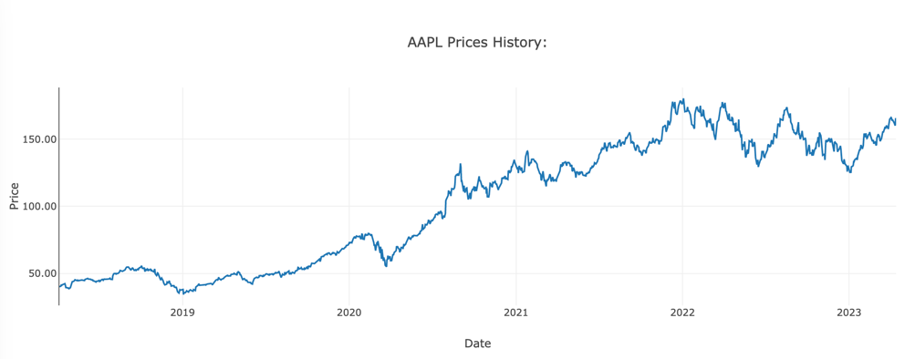

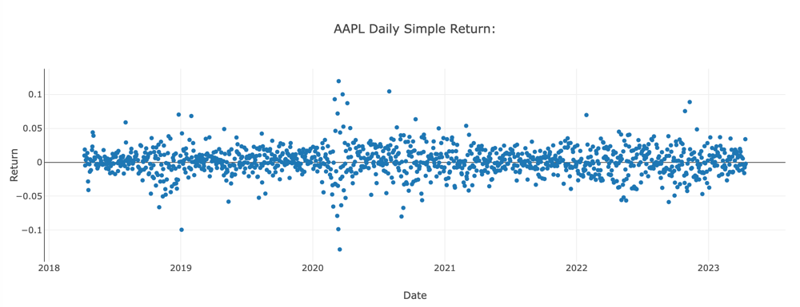

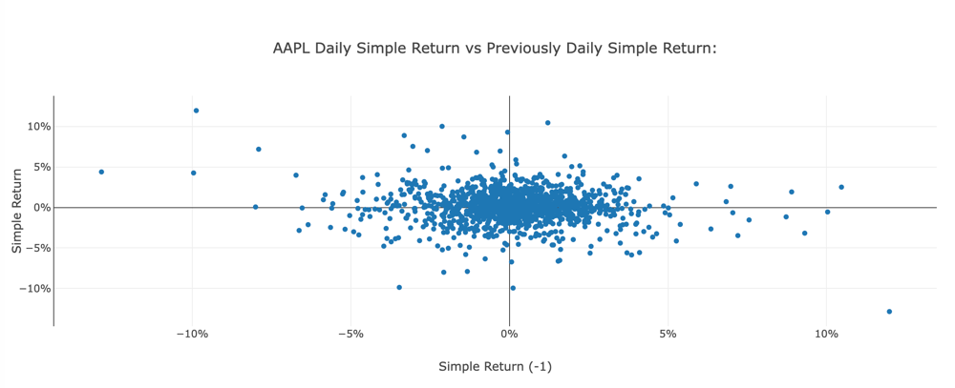

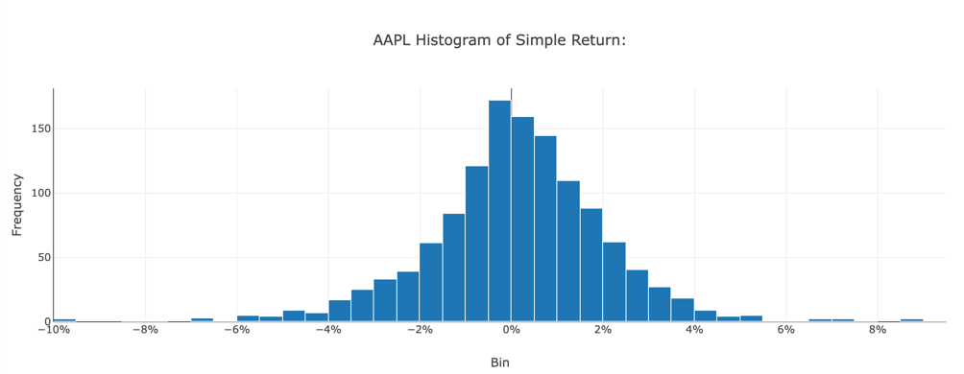

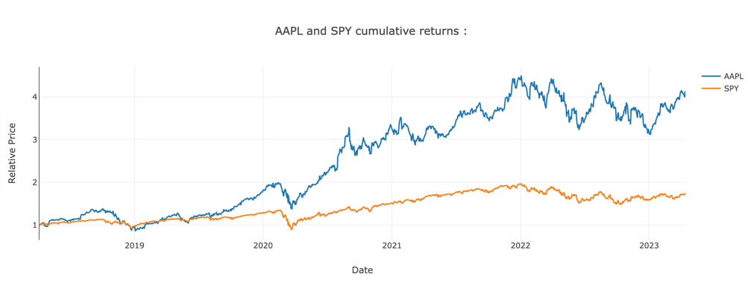

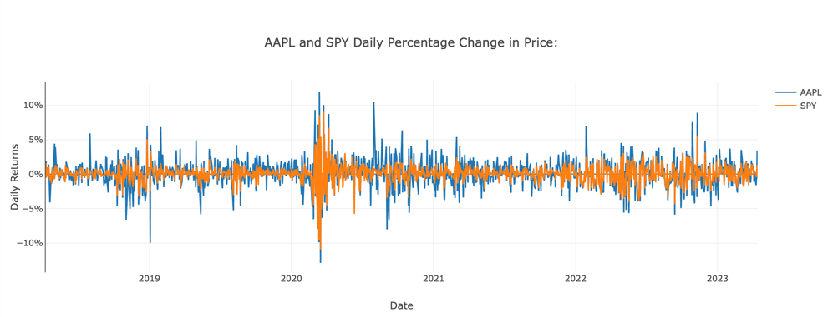

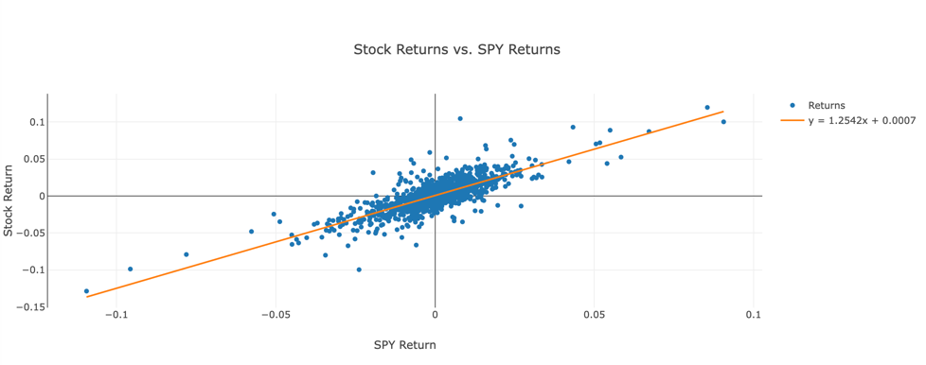

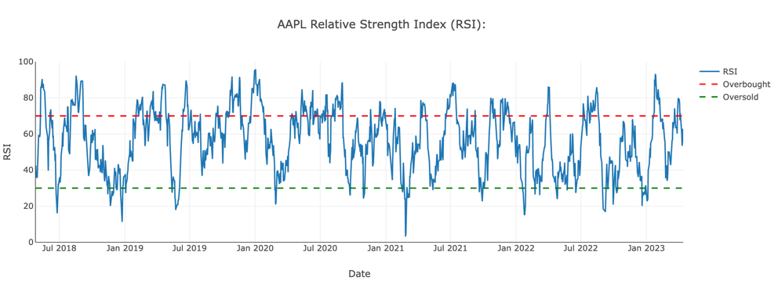

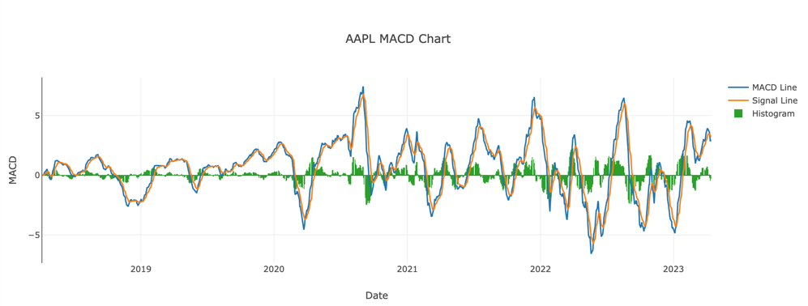

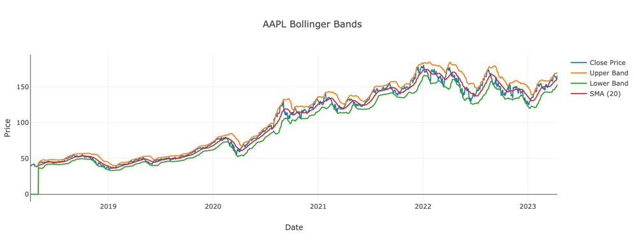

2.

Input: To see the EF graph for user’s portfolio.

For example, my portfolio:

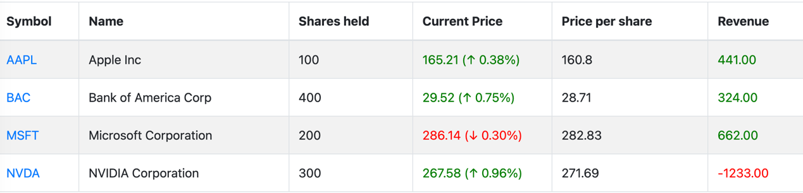

Output:

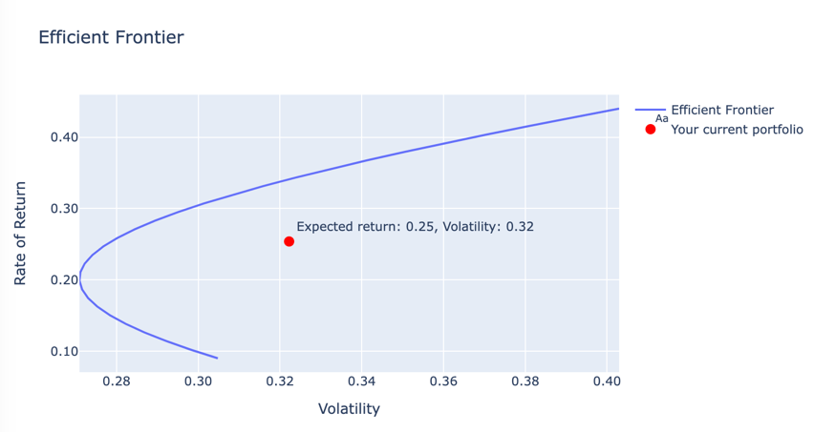

3.

Input: To see the EF graph for user’s portfolio when the number of stocks in current portfolio is less than 2.

Output: Reminder: There are less than 2 stocks in the overall portfolio.

**Requirement 9**

Check that all the charting features and controls are present and functioning correctly.

Ensure that the layout and design elements match the wireframes and prototype.

Verify that the charts update in real-time when new data is added.

Verify that all text and visual elements have appropriate contrast and are readable.

Welcome page:





Log in page:



Sign up page:



Admin page:  
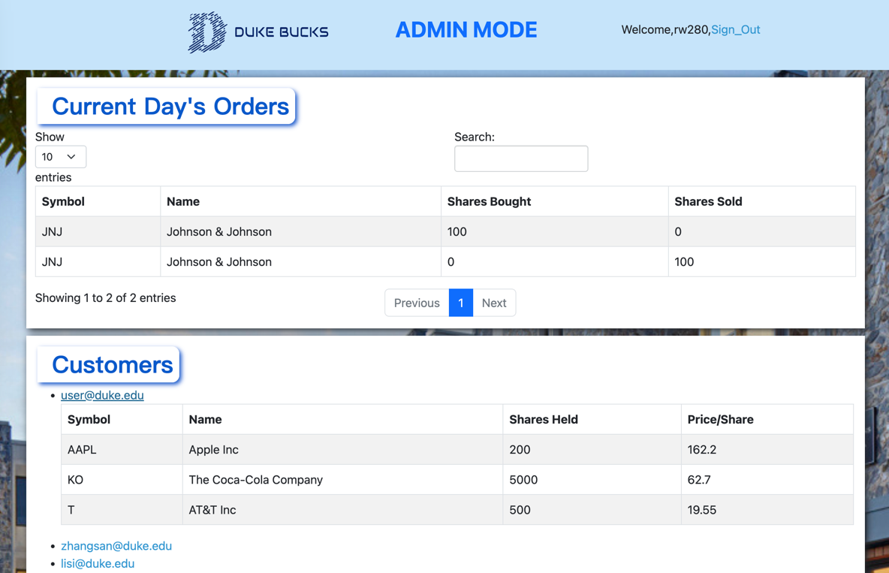

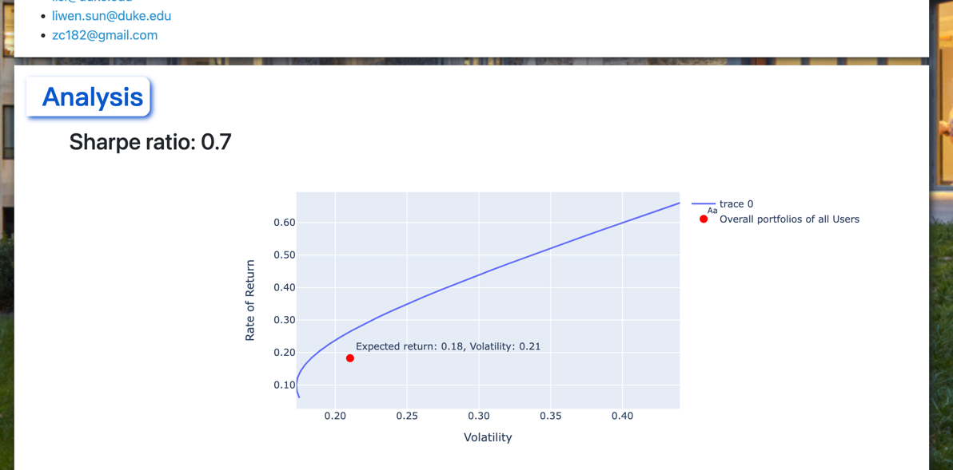

Finance home:

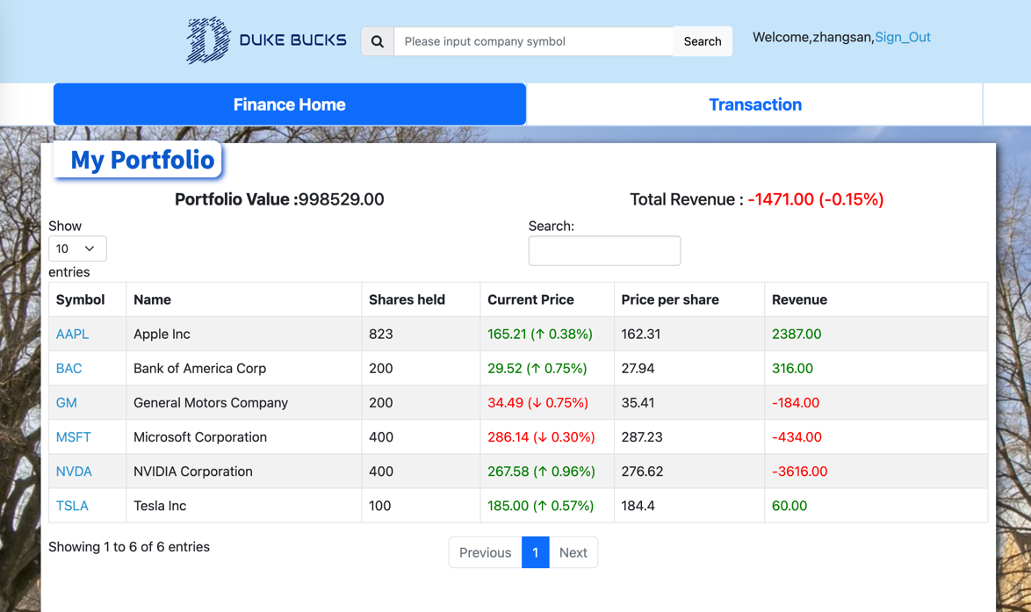

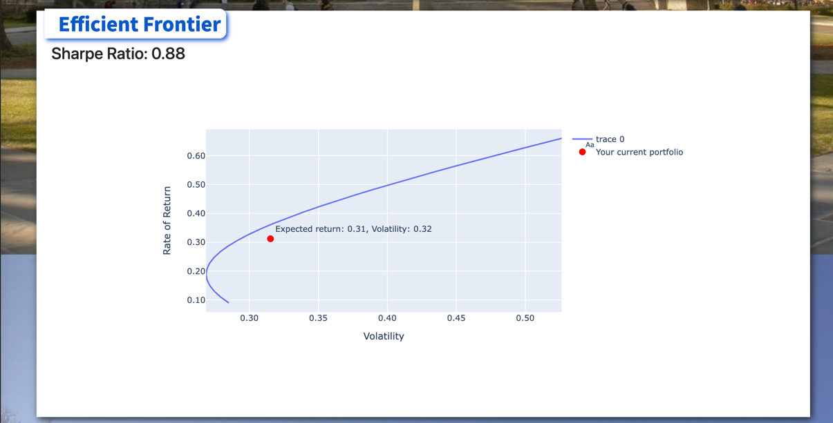

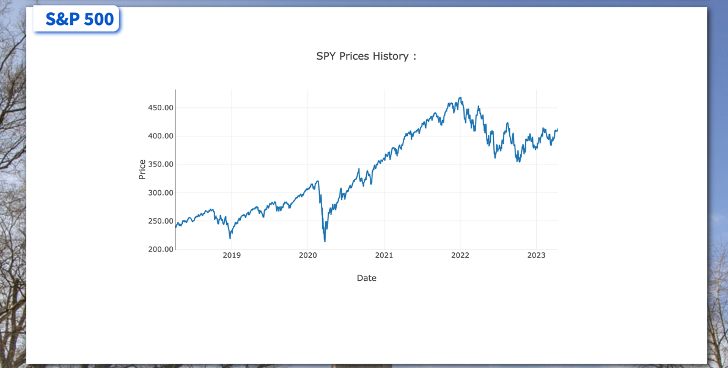

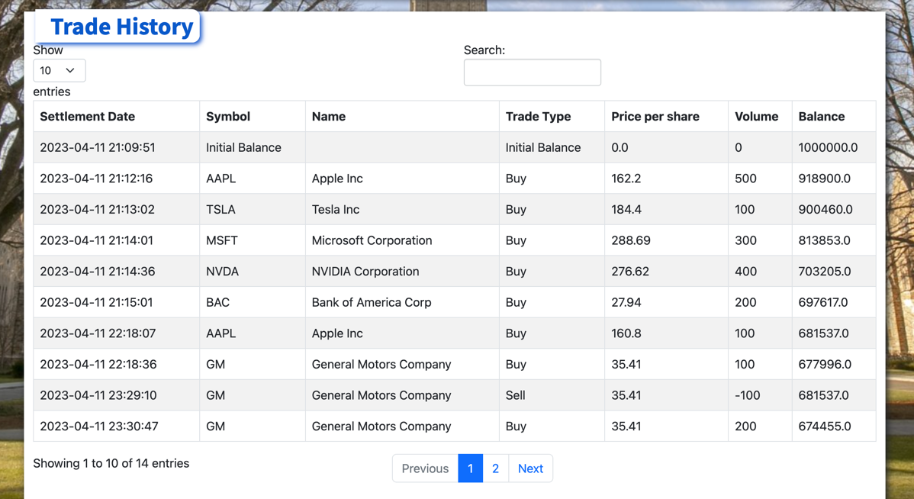

Transaction: e.g. AAPL

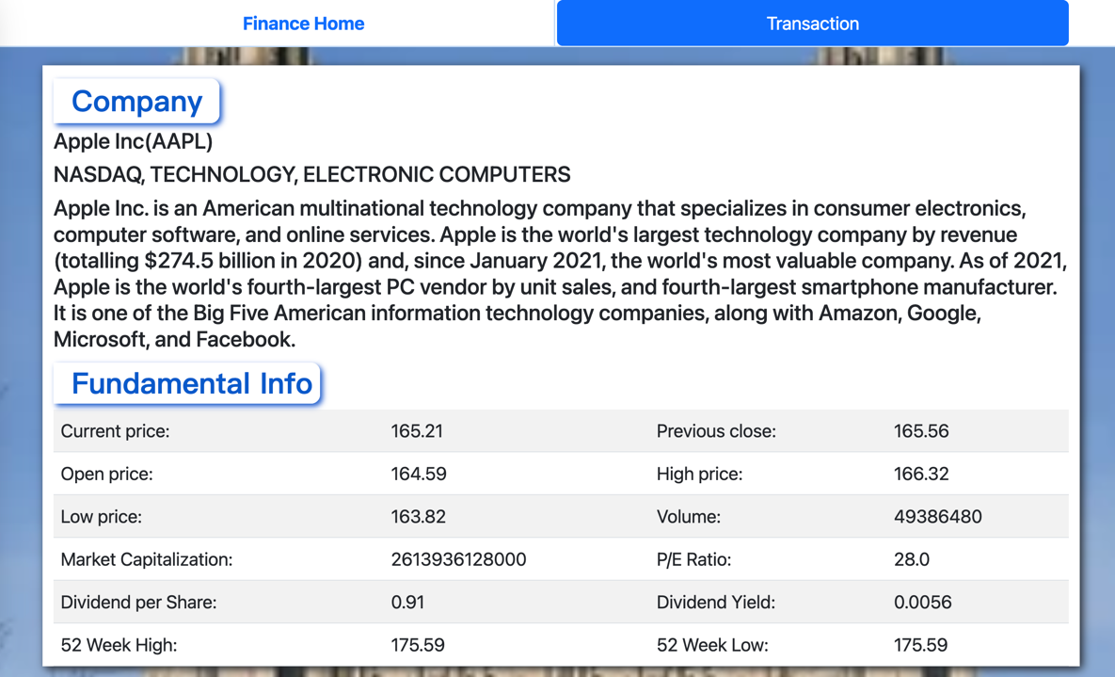

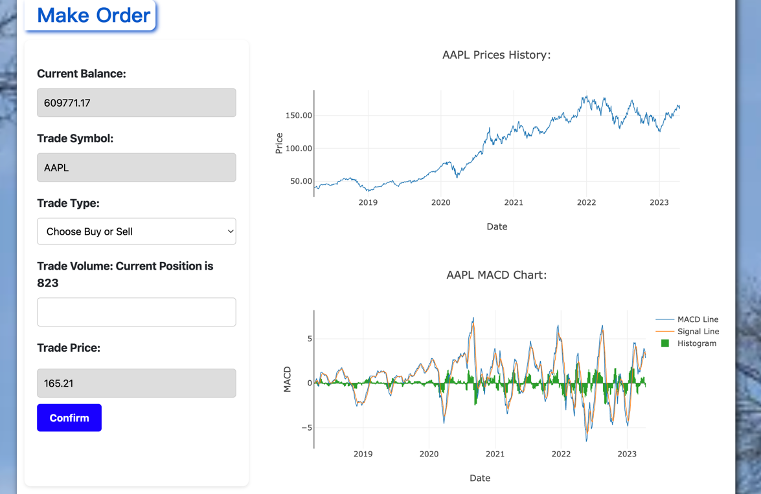

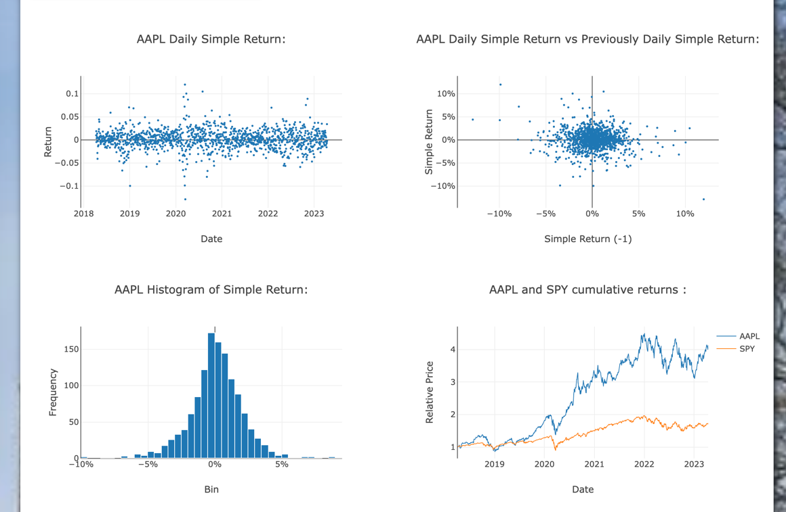

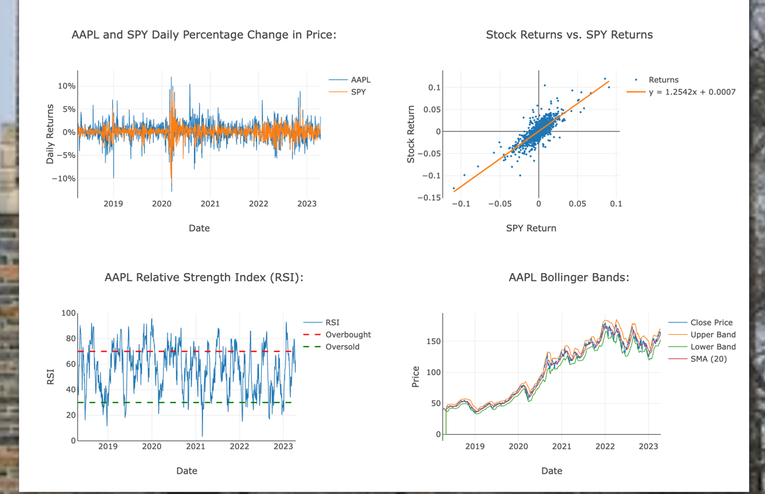



**Requirement 11:**

Test that the change in price is correctly calculated as the difference between the current price and the opening price.

Test that the real-time revenue change is correctly calculated based on the current stock price and the number of shares owned.

Test that growth is displayed in green, and decline is displayed in red, according to the described color scheme.

Test that the data in the portfolio table is refreshed every five seconds.

Test that the portfolio table is displayed correctly and consistently across different browsers and devices.

